DATA SCIENCE
PROJECT REPORT
(Project Semester January-April 2025)
Understanding Regional Spread: Population, Household, and Area
Submitted by
(Priteek Singh Manhas)
Registration No: 12326131
Programme and Section: Data Science : Introduction to data management KM005
Course Code: INT217
Under the Guidance of
(Baljinder Kaur UID 31770)
Discipline of CSE/IT
Lovely School of Computer Applications
Lovely Professional University, Phagwara

DECLARATION
I, Priteek Singh Manhas, student of Data Management under CSE/IT Discipline at Lovely Professional University, Punjab, hereby declare that all the information furnished in this project report is based on my own intensive work and is genuine.
Date: 12-04-2025
Signature:PriteekSingh
Registration No.12326131
Name of the student Priteek Singh Manhas

CERTIFICATE

This is to certify that Priteek Singh Manhas bearing Registration no. 12326131 has completed Introduction to data management project titled, “Understanding Regional Spread: Population, Household, and Area” under my guidance and supervision. To the best of my knowledge, the present work is the result of his/her original development, effort and study.

Signature and Name of the Supervisor
Baljinder Kaur
Designation of the Supervisor
School of Computer Science and Engineering
Lovely Professional University
Phagwara, Punjab.

Date: 12-04-2025

ACKNOWLEDGEMENT
I would like to express my sincere gratitude to my faculty mentor for their invaluable guidance, support, and encouragement throughout the course of this project. Their insights and suggestions helped shape the direction and quality of this work.
I also acknowledge Lovely Professional University for providing the resources and opportunity to work on this project.

TABLE OF CONTENTS
1. Introduction
2. Source of Dataset
3. Dataset Preprocessing
4. Analysis on Dataset
i. General Description
ii. Specific Requirements
iii. Analysis Results
iv. Visualization
5. Conclusion
6. Future Scope
7. References

1. Introduction

Understanding the distribution of population, households, and land area is critical for effective governance, urban planning, and infrastructure development. This project presents a comprehensive dashboard and analysis framework for regional demographic statistics across India. The goal is to uncover meaningful patterns in settlement types, population density, and household clusters. The dashboard provides an intuitive and interactive platform to explore this complex dataset at different levels of granularity—from state to sub-district levels.

2. Source of Dataset

The dataset used in this project originates from publicly available Indian census and regional data sources compiled into an Excel spreadsheet. The Excel file contains structured data representing population counts, area in square kilometers, numbers of towns and villages, household counts, and population density across various administrative levels. The key source sheet for this project is titled 'Dashboard_Data', which serves as the backbone of the interactive dashboard built in Excel.

3. Dataset Preprocessing

Data preprocessing was conducted directly in Microsoft Excel using built-in functions and tools. Key preprocessing steps included:

Filtering and Sorting: Data was cleaned to retain only relevant rows (i.e., actual region records, excluding totals or headers).

Use of Excel Functions: Functions such as IF(), ISNUMBER(), and TRIM() were used to clean and normalize data entries.

Column Adjustments: Empty columns were removed or replaced with derived values where appropriate.

Categorical Data Handling: 'Region_Name' and 'Area' fields were used to distinguish between administrative levels (India, State, District, Sub-District).

Validation: All numeric columns were validated using conditional formatting to highlight missing or anomalous values for manual review.

This ensured a clean and structured dataset ready for integration into the interactive dashboard.

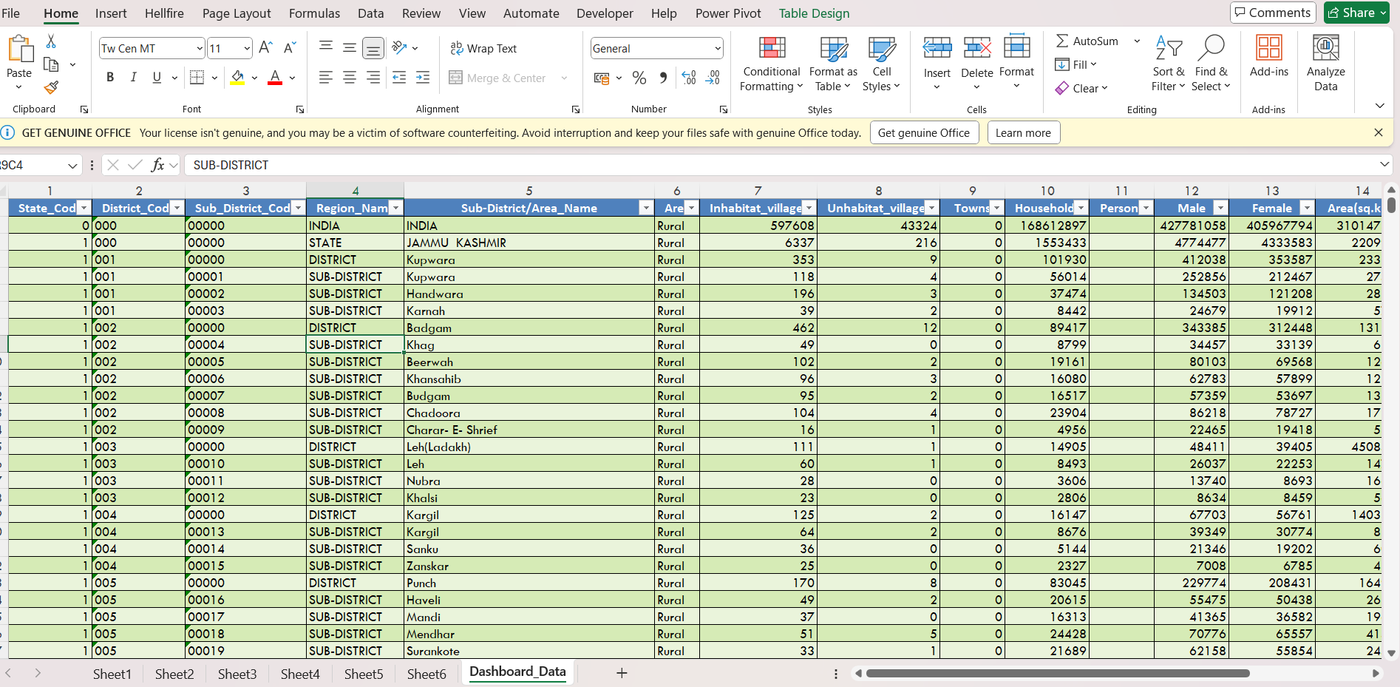

4. Analysis on Dataset

i. General Description

The dataset comprises multi-level demographic and geographic information across the Indian region. Each record corresponds to a geographic unit such as a sub-district, district, or state, and contains detailed statistics on total population, number of households, area in square kilometers, number of towns and villages, and population density. The hierarchy helps reveal patterns in how people are distributed across India's rural and urban landscape.

ii. Specific Requirements

The project aimed to meet the following requirements:

Build an interactive dashboard to explore demographic spread visually.

Allow filtering by geographic level (State/District/Sub-District).

Provide comparative visuals for population density and household distribution.

Ensure the data preprocessing was traceable and reproducible using Excel functions.

Maintain clarity for use in academic or policy discussions.

iii. Analysis Results

Analysis revealed several notable patterns:

States with high population density include smaller geographic areas with concentrated populations.

Sub-districts with larger areas do not always correlate with higher household counts.

Urban regions show a distinct pattern of fewer villages but more concentrated household clusters.

Visualization of total population by district helps spot both overpopulated and underserved regions.

iv. Visualization

Charts were embedded in the Excel dashboard including:

Bar charts of state-wise population and area.

Pie charts of household distribution.

Line graphs showing comparative trends.

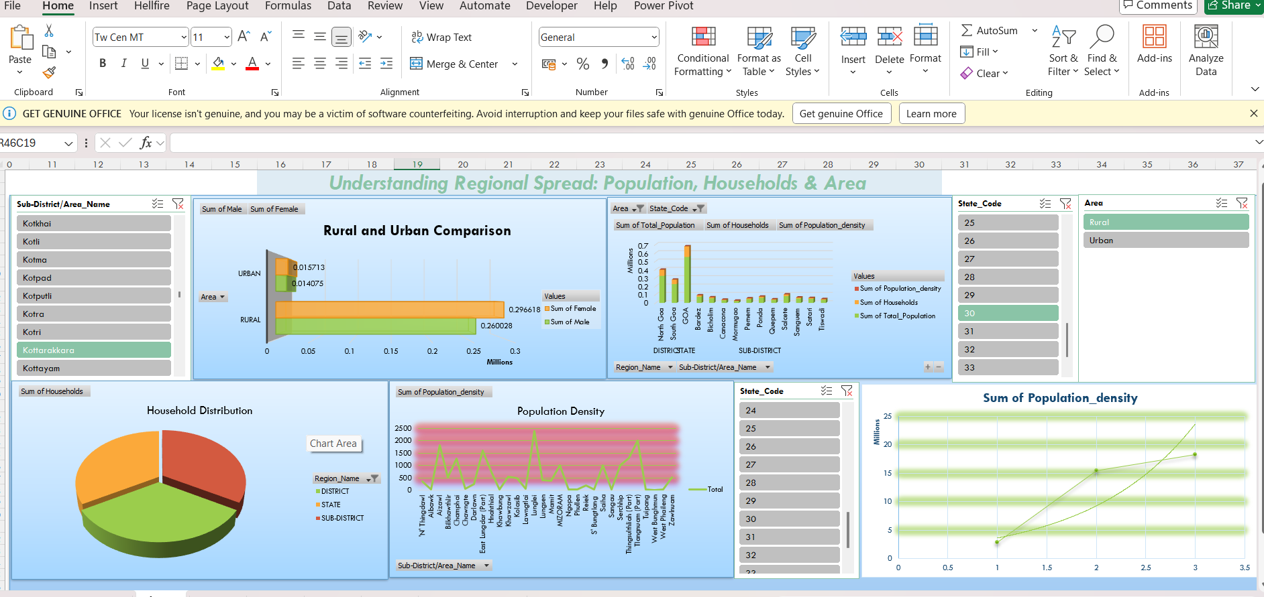

5. Interactive Excel Dashboard

The dashboard was built using Microsoft Excel’s Pivot Tables, Slicers, and Charting Tools. Users can interactively filter data based on regions, states, or area types. The dashboard helps explore relationships between population, household count, and geographical area using a user-friendly interface.

6. Conclusion

This project provides a detailed and accessible way to explore regional demographic patterns using Excel. The insights derived can support policy decisions in urban planning, development schemes, and resource allocation. The integration of Excel’s functionality for both data cleaning and dashboard building demonstrates the strength of spreadsheet tools in data science workflows.

7. Future Scope

Future work could involve linking this demographic data with environmental indicators such as rainfall, temperature, and natural resources. Additionally, automation using Python or Power BI could allow even more scalable and dynamic dashboard functionality, as well as historical time-series tracking for trend analysis.

8. References

[1] Government of India Census Data
[4] Regional Planning Reports and Statistics

LinkedIn Post